Name : Muhammad Qasim Ashfaq
Roll : SU92-BSAIM-S25-030
Student Data Set Information
This dataset contains comprehensive information on 2,392 high school students, detailing their demographics, study habits, parental involvement, extracurricular activities, and academic performance. The target variable, Grade Class, classifies students' grades into distinct categories, providing a robust dataset for educational research, predictive modelling, and statistical analysis.
Kaggle Link:
Data Set (Click Here)

Lab-Task 10
It’s Primarily an extension to the Lab Task 9 submitted before it.
Additional Changes Made to it are:
- Identification of missing Values
- Filling of Missing Values
- Identification of Duplicate Values for a Feature
- Removal of Duplicate Values, if there is any.
- Descriptive Statistics (Mean, Median, Mode, Standard Deviation etcetera)
- Categorical Feature Analysis

Missing Values:
To find any missing values I used “data.isnull().sum()”
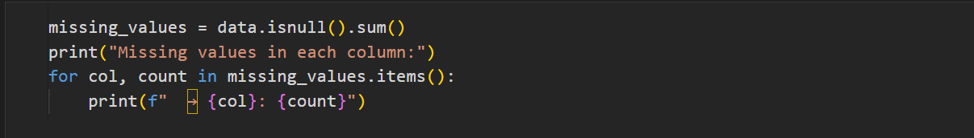
Then the missing values for each Column are represented as a beautiful pattern on the screen:
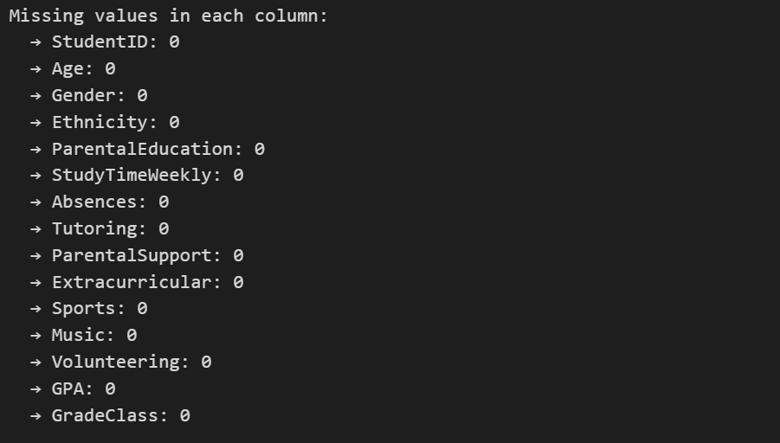

Filling Data:
Replace all “NaN” values with a specific number or string “data.fillna(0)”
Here , Forward or Backward fill could also be used to achieve the results.

Identification of Duplicate Values:
For Duplicates inside a column , we use the built in “Pandas Function” called “.duplicated()”
In coding style , we can write it as:
“duplicates = data.duplicated().sum()”
“.sum()” will display the count of all the duplicate values present in the data column we are inspecting.

Removal of Duplicates:
To remove duplicate values in a Pandas Data Frame, the primary method is “drop_duplicates()”
new = data.drop_duplicates(keep = “first”, inplace = True)
keep = “first” keeps the first instance of the Data Value that is repeated
inplace = True , it embeds the changes in the original dataset rather than returning a new data frame.

Descriptive Statistics:
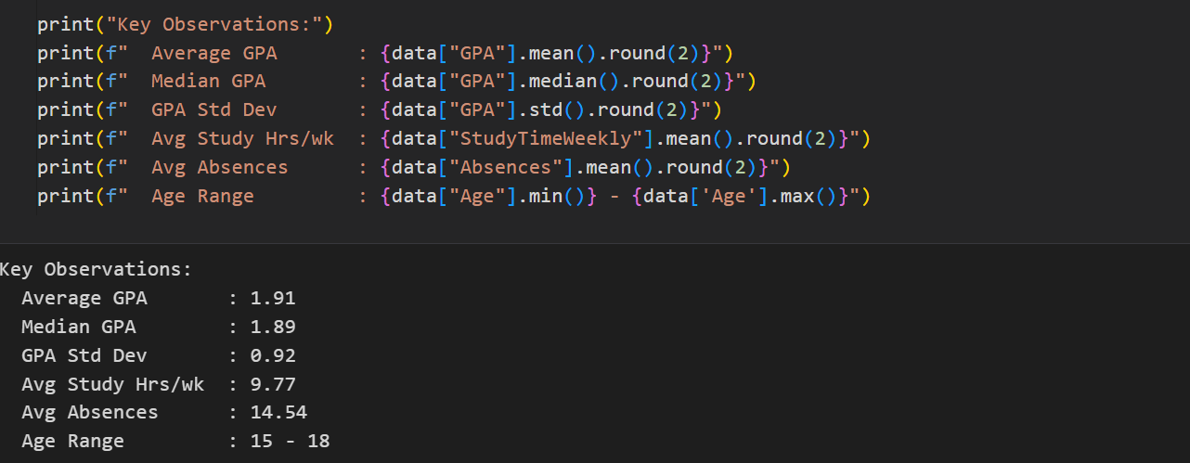
- Mean , Median , Standard deviation of “GPA” Column in the data is being displayed through built in pandas functions “.mean() , .median() , .std()”
- Minimum and Maximum Value of Age in the dataset can also be displayed using .min() and .max() respectively.
- The function .round() rounds off the floating-point value to a limited decimal point.

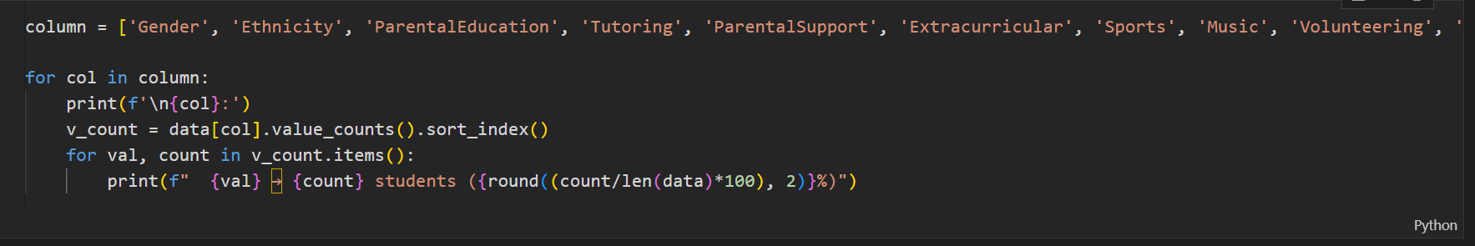
Categorical Feature Analysis:

- The Column Names of dataset are given as a list “column”
- “for” loop iterates between the column names (printing the column name in each iteration)
- Then by using the function .value_counts() , and subsequently using “for” loop for items in the value count , each categorical Feature and its classification percentage is displayed on the screen (For example , Gender : (male% , Female%)

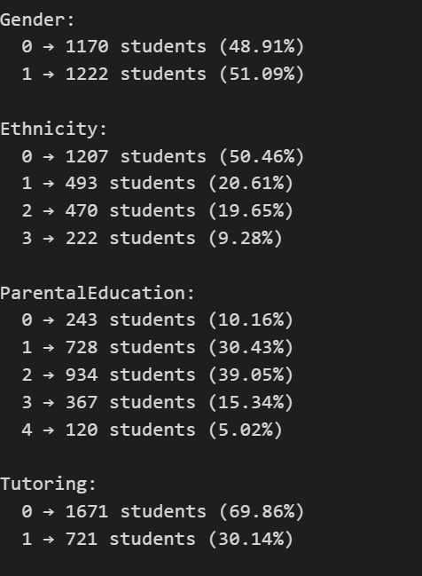

Changing The Datatype of a certain Column:
